**PROJECT REPORT**

**ON**

***HappyTails***

**BY**

**Sakshi Nikalje**

**SAVITRIBAI PHULE PUNE UNIVERSITY**

**MASTER IN COMPUTER APPLICATION**

**MAHARASHTRA EDUCATION SOCIETY’s**

**INSTITUTE OF MANAGEMENT AND CAREER COURSES**

**(IMCC), PUNE-411038**

**2024-25**

**CERTIFICATE**

This is to certify that the Sakshi Nikalje has completed the project work entitled “*HappyTails”* under my guidance. The report is submitted in partial fulfillment of M.C.A. Course for the Academic Year 2024-2025 as per the rules & prescribed guidelines of Savitribai Phule Pune University.

His/her work is found to be satisfactory and complete in all respects.

**Dr. Jayashree Patil**

**(Internal Project Guide)**

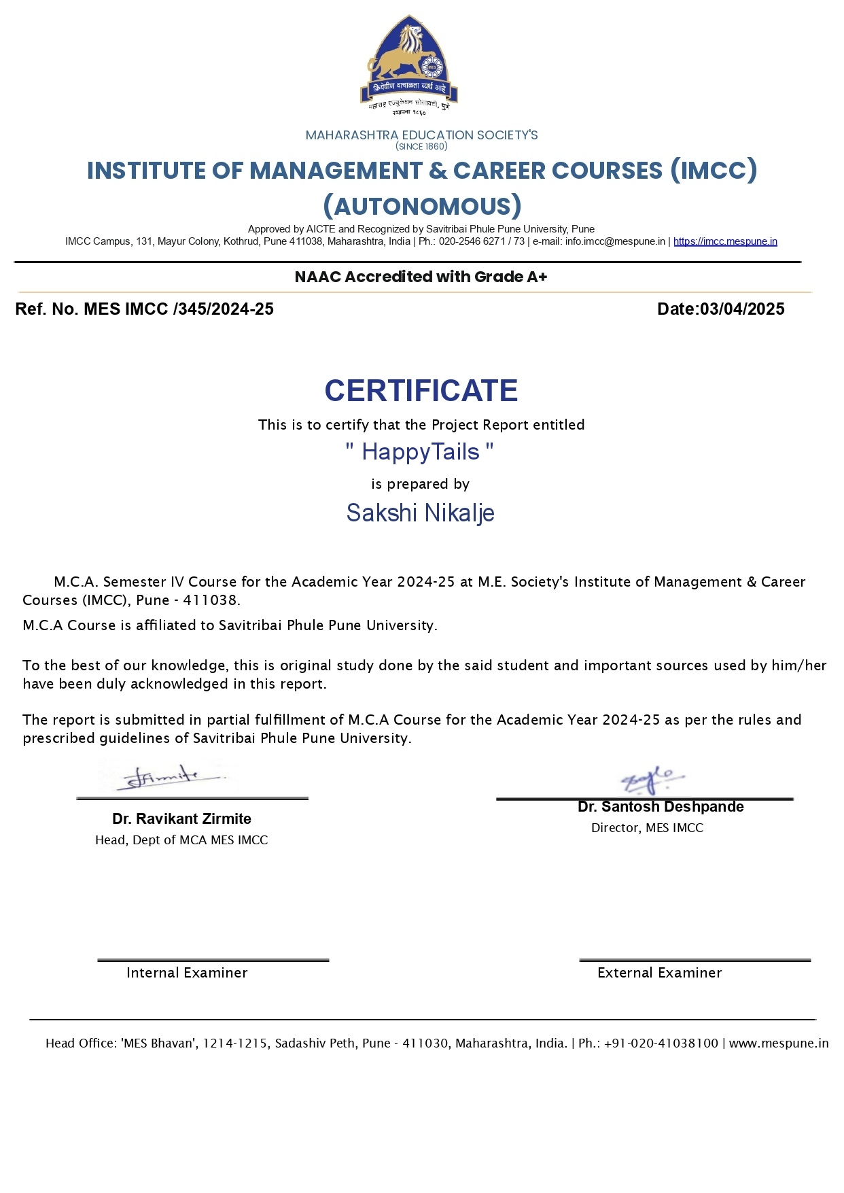

**Acknowledgement**

I would like to express my sincere gratitude to our internal project guide, Dr. Jayashree Patil, her exceptional organizational skills have been instrumental in keeping the project on track and ensuring timely delivery. Her guidance, expertise, and unwavering support have been invaluable throughout the project journey.

I am also deeply thankful to our Head of Department, Dr. Ravikant Zirmite, for his insightful inputs and continuous support. His wisdom and encouragement have greatly contributed to the success of our project.

Special thanks are due to our esteemed Director, Dr. Santosh Deshpande, and Deputy Director, Dr. Manasi Bhate, for their invaluable guidance and encouragement. Their vision and leadership have been a source of inspiration for us.

I extend my heartfelt appreciation to all individuals mentioned above for their strong belief in me and their dedication to our project's success.

**INDEX**

|  |  |  |  |
| --- | --- | --- | --- |
| Chapter no. |  | Title | Page. |
| 1 |  | **Introduction** |  |
|  | 1.1 | Institute profile | 1 |
|  | 1.2 | Abstract | 1 |
|  | 1.3 | Existing system and Need for system | 2 |
|  | 1.4 | Project scope | 2-3 |
|  | 1.5 | Operating Environment | 3-4 |
|  | 1.6 | Brief description of technology used | 4-5 |
| 2 |  | **Proposed** **System** |  |
|  | 2.1 | Study of similar systems | 9-10 |
|  | 2.2 | Feasibility study | 10 |
|  | 2.3 | Objectives of proposed system | 11 |
|  | 2.4 | Users of system | 12 |
| 3 |  | **Analysis and Design** |  |
|  | 3.1 | System requirements | 14-15 |
|  | 3.2 | Entity Relationship Diagram | 16 |
|  | 3.3 | Table structure | 17-21 |
|  | 3.4 | Use Case Diagram | 22 |
|  | 3.5 | Class Diagram | 23 |
|  | 3.6 | Activity Diagram | 24 |
|  | 3.7 | Deployment Diagram | 25 |
|  | 3.8 | Module Hierarchy Diagram | 26 |
|  | 3.9 | Sample Input and Output Screens | 27-32 |
| 4 |  | **Coding** |  |
|  | 4.1 | Code Snippets | 34-35 |
| 5 |  | **Testing** |  |
|  | 5.1 | Test Strategy | 37-38 |
|  | 5.2 | Unit Test Plan | 39-43 |
|  | 5.3 | Acceptance Test Plan | 44-50 |
|  | 5.4 | Test Case/ Test Script | 51-54 |
|  | 5.5 | Defect Report | 55-57 |
| 6 |  | **Limitations of Proposed System** | 58 |
| 7 |  | **Proposed Enhancements** | 59 |
| 8 |  | **Conclusion** | 60 |
| 9 |  | **Bibliography** | 61 |
| 10 |  | **User Manual** | 62-71 |

Chapter 1

**INTRODUCTION**

* 1. **Institute profile**

The Institute popularly known as IMCC was established in 1983 by   M. E. Society for providing quality education and technical expertise at the Post Graduation Level in the Fields of Computers and Management. The Institute is recognized by SPPU under Section 46 of Pune University Act, 1974 and Section 85 of Maharashtra University Act, 1994. The Institute is located at 131, Mayur Colony, Kothrud, Pune-411 038 .

**1.2. Abstract**

HappyTails is a MERN-based web platform designed to streamline pet adoption and management by connecting pet owners, adopters, and administrators. The system provides a centralized and user-friendly solution where users can browse, list, and adopt pets, while admins can manage pet listings, adoption requests, and pet-related services. Additionally, the system integrates adoption request tracking, ensuring a transparent and structured process. The inclusion of pet services enhances the platform’s functionality by providing users access to essential pet care resources. HappyTails aims to simplify pet adoption and promote responsible pet care in a digital-first approach.

**1.3. Existing System and Need for System**

**1.3.1. Existing System**

Currently, pet adoption and management are often handled through traditional methods such as social media posts, word-of-mouth, or offline pet shelters. But there are few limitations like limited service access, manual adoption process, no proper pet management, etc. Also there is no dedicated system where users can browse available pets and request adoptions efficiently.

**1.3.2. Need for the System**

HappyTails aims to provide a web platform with multiple features. Admins can manage pet listings, approve/reject adoption requests, and update available services. Users can submit adoption requests directly, ensuring a structured and efficient process. A secure login system (Admin & User) to provide a personalized dashboard for each role. This system will streamline pet adoption, improve accessibility to pet services, and provide a centralized platform for pet lovers.

**1.4.** **Project Scope**

The project involves developing a user-friendly website where users can browse available pets for adoption, submit adoption applications, and connect with shelters or pet owners. The platform will include an intuitive admin panel for managing pet listings, adoption requests, and user accounts. It will enable both pet owners and adopters to create and manage their profiles, track adoption requests, and communicate seamlessly. The platform will integrate pet care services, such as grooming and daycare center listings, where users can explore service providers, view their offerings, and contact them. An e-commerce module will allow users to purchase pet food, toys, and accessories through a secure and user-friendly online store.

**1.5. Operating Environment**

1. Frontend

* **Framework:** React.js
* **State Management:** Context API
* **Styling:** CSS
* **Port:** localhost:3001

2. Backend

* **Runtime Environment:** Node.js
* **Framework:** Express.js
* **Authentication:** JSON Web Token (JWT) for user and admin login
* **Database:** MongoDB (petManagement database)
* **ORM:** Mongoose
* **Port:** localhost:5000

3. Database

* **Database Type:** NoSQL
* **DBMS:** MongoDB (Cloud: MongoDB Atlas or Local: MongoDB Compass)
* **Collections:**
  + users (for user and login)
  + pets (for pet listings)
  + adoptionrequests (for adoption form submissions)
  + products (for pet-related eCommerce items)
  + services (for service listings)

**1.6. Brief description of technology used**

1. Frontend (React.js)

* **React.js:** A JavaScript library for building dynamic UI components.
* **React Router:** Enables navigation between different pages without reloading.
* **CSS:** Used for styling and responsive design.

2. Backend (Node.js & Express.js)

* **Node.js:** A JavaScript runtime environment that allows running JavaScript outside the browser.
* **Express.js:** A lightweight framework for building REST APIs and handling server-side logic.
* **JWT (JSON Web Token):** Used for secure authentication of users and admins.

3. Database (MongoDB & Mongoose)

* **MongoDB:** A NoSQL database to store user data, pets, products, and adoption requests.
* **Mongoose:** An Object Data Modeling (ODM) library for interacting with MongoDB using JavaScript.

Chapter 2

**PROPOSED SYSTEM**

**2.1. Study of Similar Systems**

**1. Petfinder**

Overview: Petfinder is a widely used pet adoption website that helps users find pets for adoption from shelters and rescue organizations.

Similarities to HappyTails:

* Users can view pet profiles, including breed, age, and location.
* Adoption request submission process.
* Shelters and individuals can list pets.

Differences:

* Petfinder primarily serves as a search engine for rescue shelters, whereas HappyTails includes pet listings from both users and the admin.
* HappyTails has an integrated product shopping and payment system.
* HappyTails features admin-controlled service listings (Grooming & Daycare).

**2. Adopt-a-Pet**

Overview: Adopt-a-Pet is a pet adoption website where animal shelters, rescues, and pet owners can list pets available for adoption.

Similarities to HappyTails:

* Adoption listing and request system.
* Filtering options for finding pets by category.
* User registration and profile management.

Differences:

* HappyTails includes eCommerce and service booking functionalities.
* Admin has direct control over service management.
* Chewy is solely an eCommerce platform, while HappyTails integrates adoption and pet services.
* HappyTails has an admin panel for managing both pets and services.
* Provides categorized pet services.
* Users can browse available services before booking.

**2.2. Feasibility Study**

**2.2.1. Technical Feasibility-**

The project will be developed using the MERN (MongoDB, Express.js, React.js, Node.js) stack, ensuring scalability, efficiency, and maintainability. MongoDB will handle pet listings, adoption requests, user profiles, and product inventories efficiently.

**2.2.2. Scalability-**

The system can be expanded with more services (vet consultations, pet insurance, etc.). The platform can be easily operated and maintained, making it operationally feasible.

**2.2.3. Operational Feasibility-**

The platform is user-friendly, with a simple UI/UX for pet parents, admins, and service providers. Admins manage pet listings, adoption approvals, and product inventory. Users (Pet Parents) browse pets, request adoptions, and shop for pet products. Service Providers manage grooming and daycare services.

**2.3. Objective of the System**

The primary objective of HappyTails is to create a centralized, user-friendly, and efficient pet adoption and management platform using the MERN stack. The system aims to bridge the gap between pet owners, adopters, and administrators, making pet adoption smoother and more accessible. Few key objectives are for enabling pet listings, dashboard for admin and users, provide access for pet services, etc. It aims to create a reliable and efficient platform that simplifies the pet adoption process while also promoting responsible pet care.

**2.4. Users of the system**

* Admin :

**Role:** Manages the entire platform, including pet listings, adoption requests, and product inventory. Admin can Approve, edit, and delete pet listings, approve or reject adoption requests, manage product listings in the eCommerce section, oversee pet services, Handle user complaints and platform maintenance, etc.

* Users (Pet parent) :

**Role:** Browse, adopt, and add pets for adoption, as well as purchase pet products. They can Browse pet listings and view pet details, submit adoption requests for pets, add their own pets for adoption, purchase pet product, etc.

* Visitors (unregistered users) :

**Role:** Explore services and product catalogs before signing up. They can view pet product listings in the products section, browse available pet services, register and login to access full features, etc.

Chapter 3

**ANALYSIS AND DESIGN**

**3.1. System Requirements –**

**3.1.1 Functional Requirements**

1. User management : Users and admins must be able to register and log in securely. Users can view and request adoption of listed pets. Admins can manage pet listings and adoption requests.
2. Pet listing and management : Users can add pets for adoption, including details like name, breed, age, gender, type, and description. Admins can add, edit, or remove pet listings. The system should display all pets (both user-added and admin-added) in a structured format.
3. Adoption request handling : Users can submit adoption requests for a pet. Admins can approve or reject adoption requests. Users can view the status of their adoption requests.
4. Service lisitng : Only admins can add, edit, and delete pet services (e.g., veterinary, grooming, training). Users can view available pet services.
5. Dashboard functionalities : Users should have a dashboard displaying their added pets and adoption requests. Admins should have a dashboard to manage pet listings, adoption requests, and services.
6. Feedback : Users can give a feedback after adoption.

**3.1.2. Non-Functional Requirements**

1. Performance : The system should handle multiple users simultaneously without lag. The database should efficiently store and retrieve pet and user data.
2. Security : User passwords must be securely hashed and stored. Only authorized users (admins) should be able to modify critical data. Adoption request details should be protected from unauthorized access.
3. Usability : The platform should have an intuitive and easy-to-navigate interface.
4. Scalability : The system should allow future enhancements, such as adding different types of pet, search filters, or chat features.
5. Reliability : The system should ensure minimal downtime and recover from failures quickly. All user actions (adoption requests, pet additions, etc.) should be accurately recorded.

**3.2. Entity Relationship Diagram (ERD)**

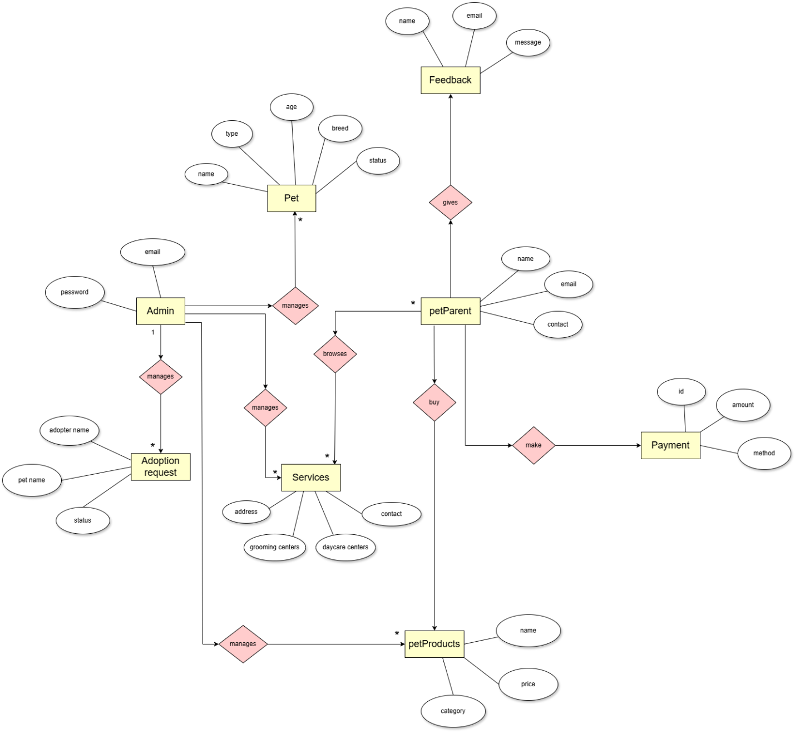

**3.3. Table structure**

* 1. users

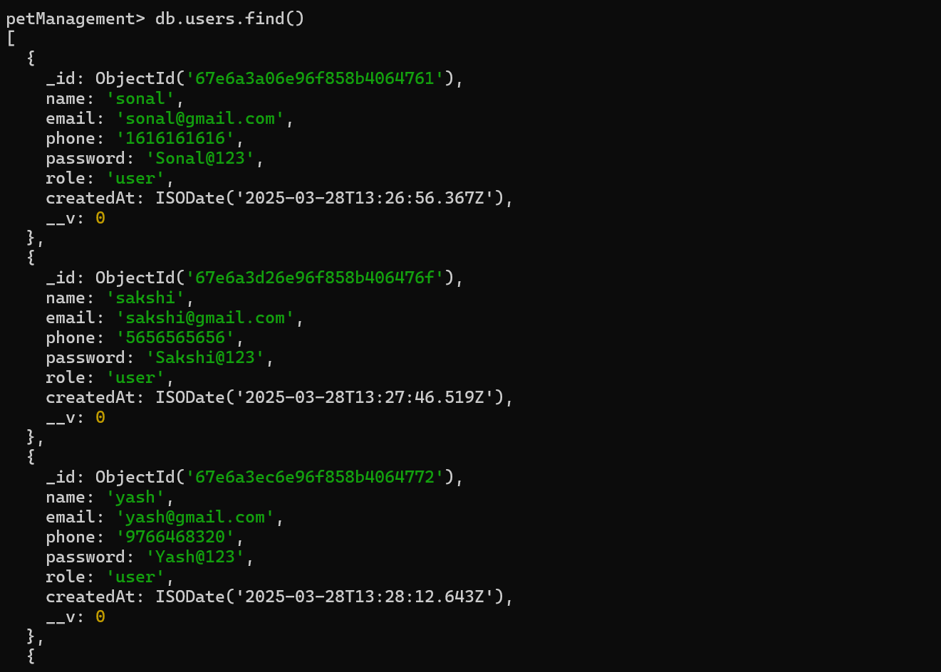

* 1. pets

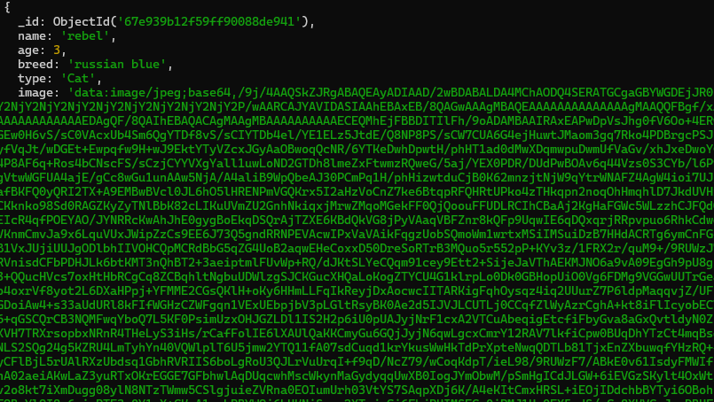

* 1. adoptionrequests

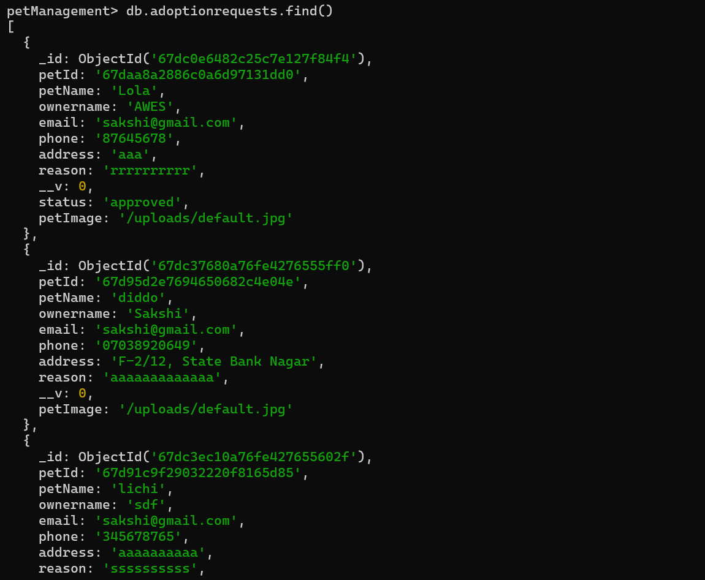

* 1. product

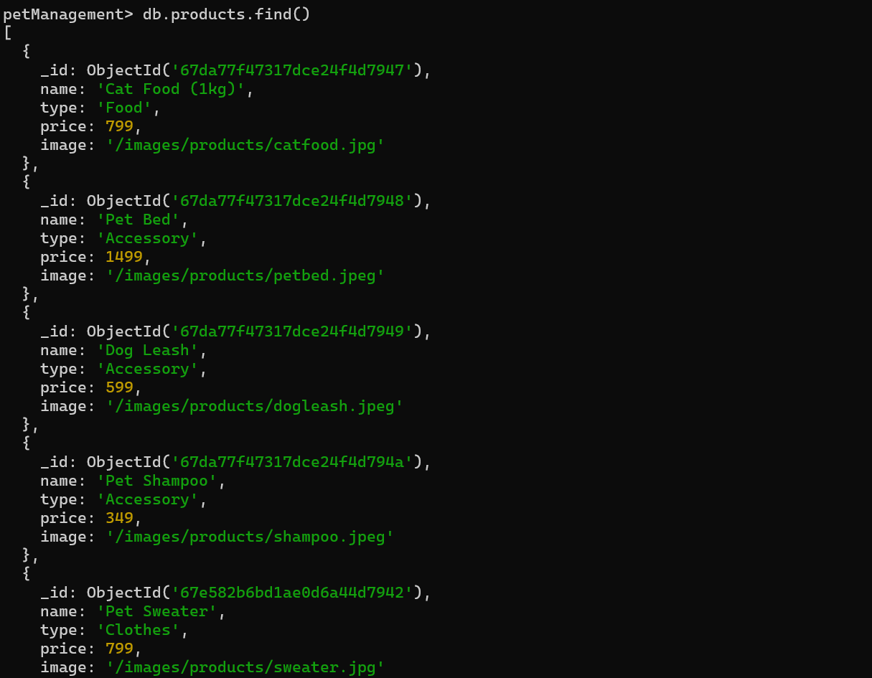

* 1. services

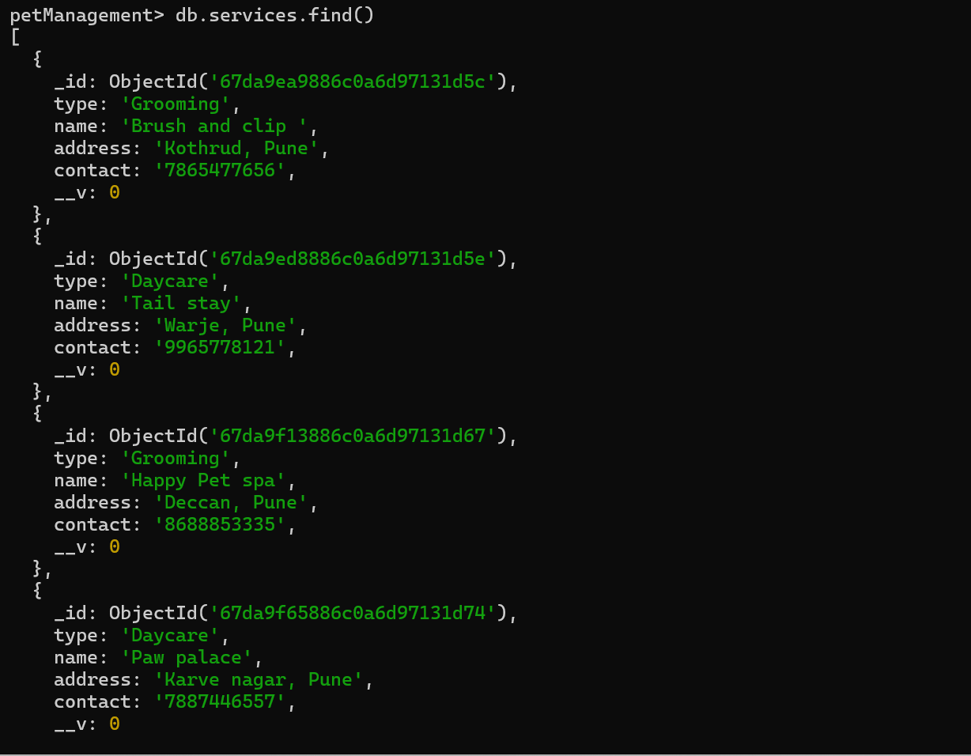

**3.4. Use case Diagram**

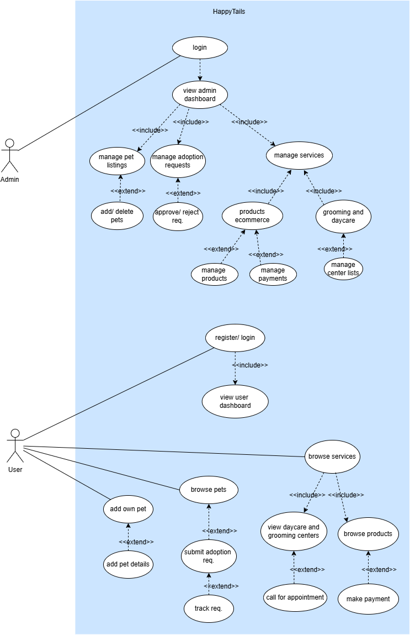

**3.5. Class Diagram**

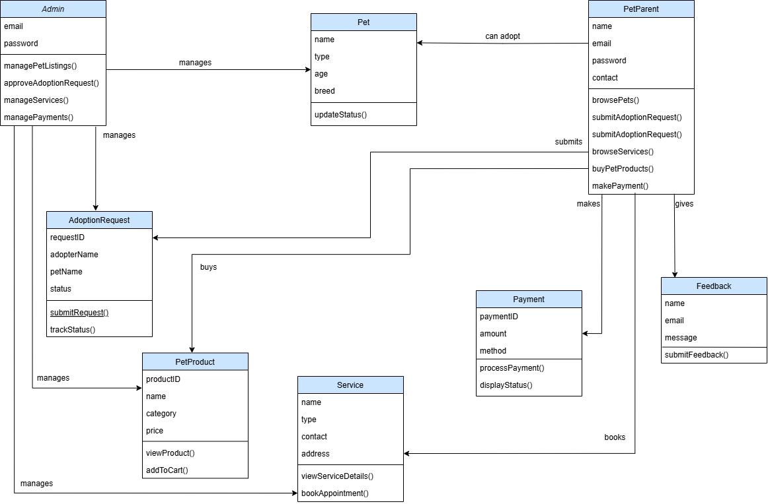

**3.6. Activity Diagram**

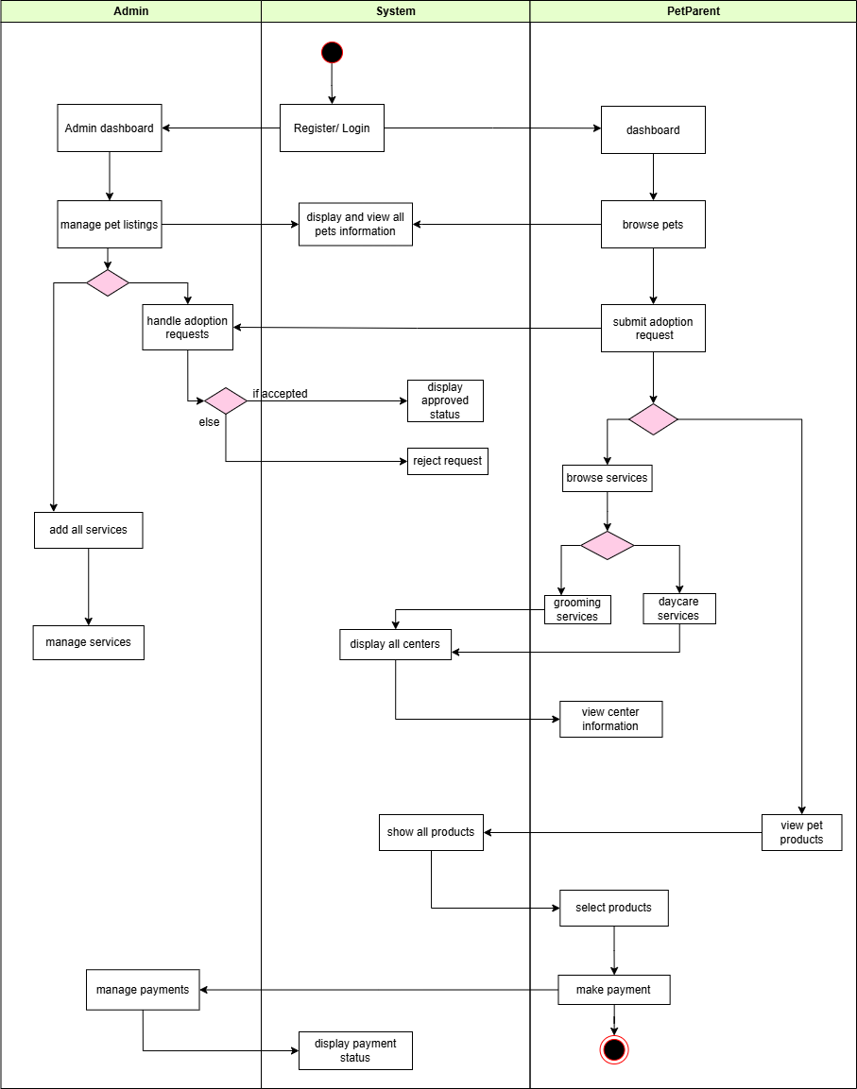

**3.7. Deployment Diagram**

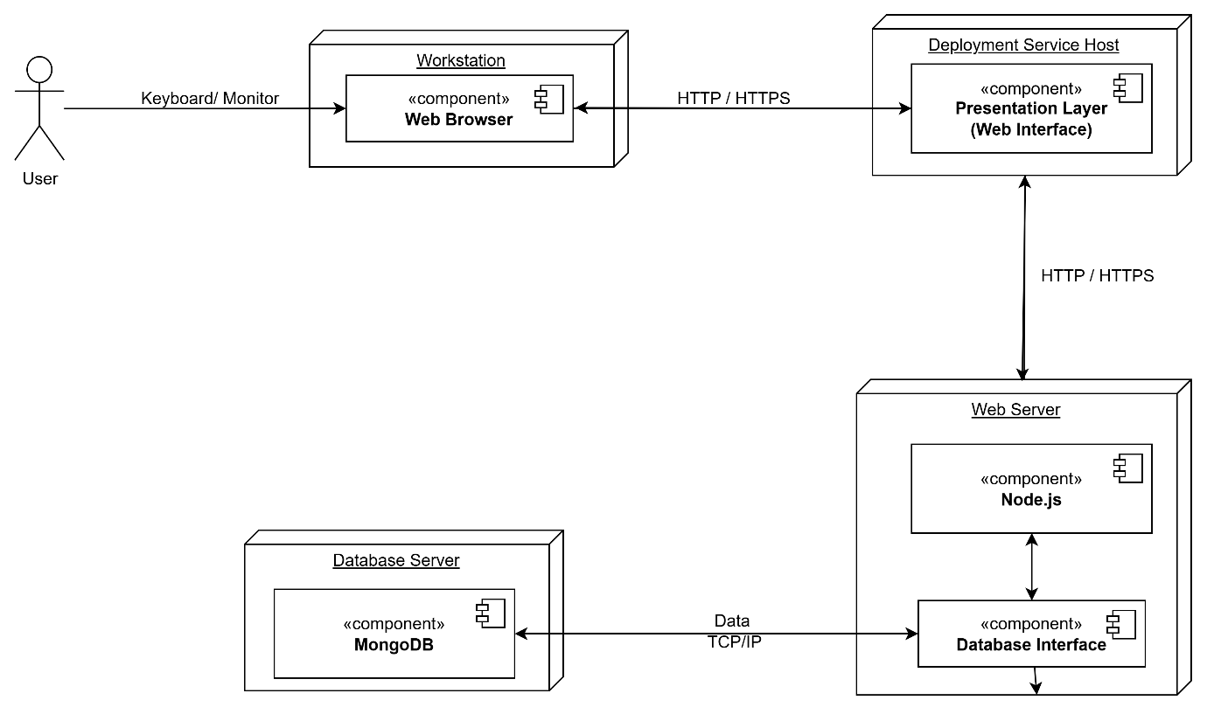

**3.8. Module Hierarchy Diagram**

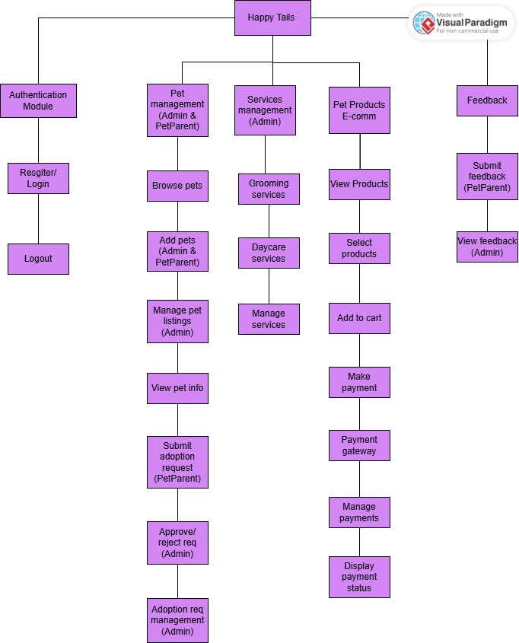

**3.9. Sample Input & Output Screens**

* 1. Home Page

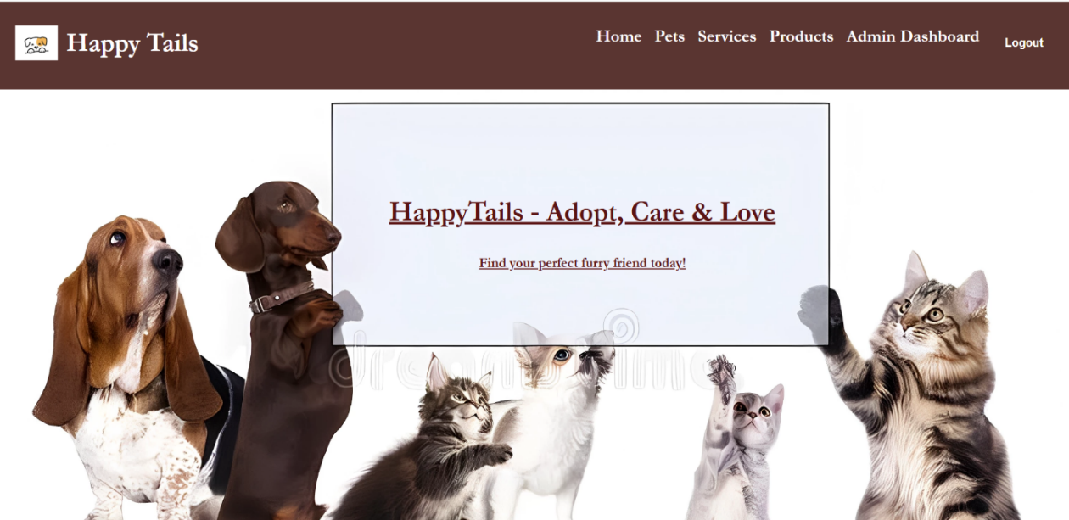

* 1. Login Page

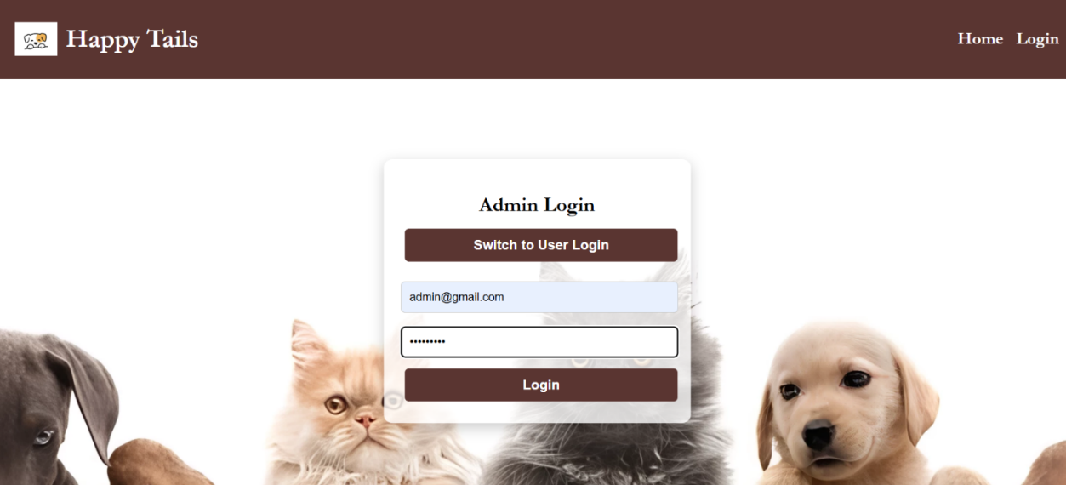

* 1. Registration Page

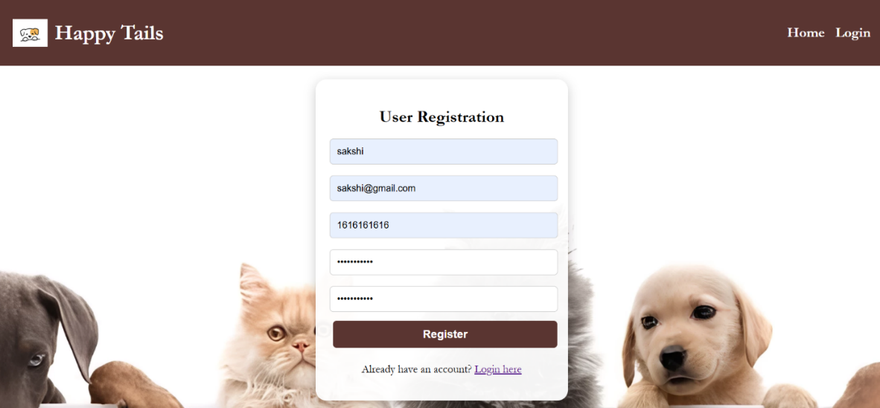

* 1. Products Page

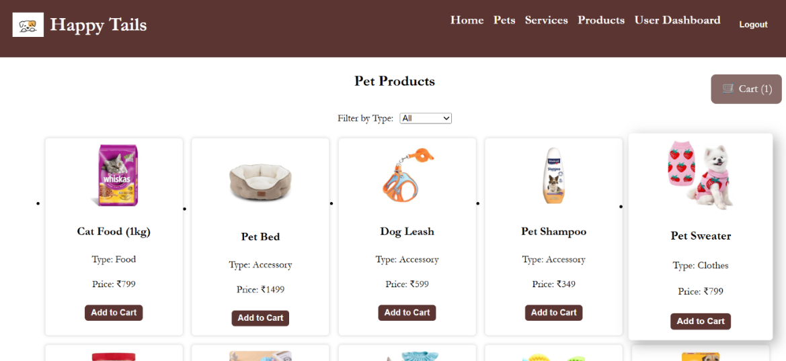

* 1. Services Page

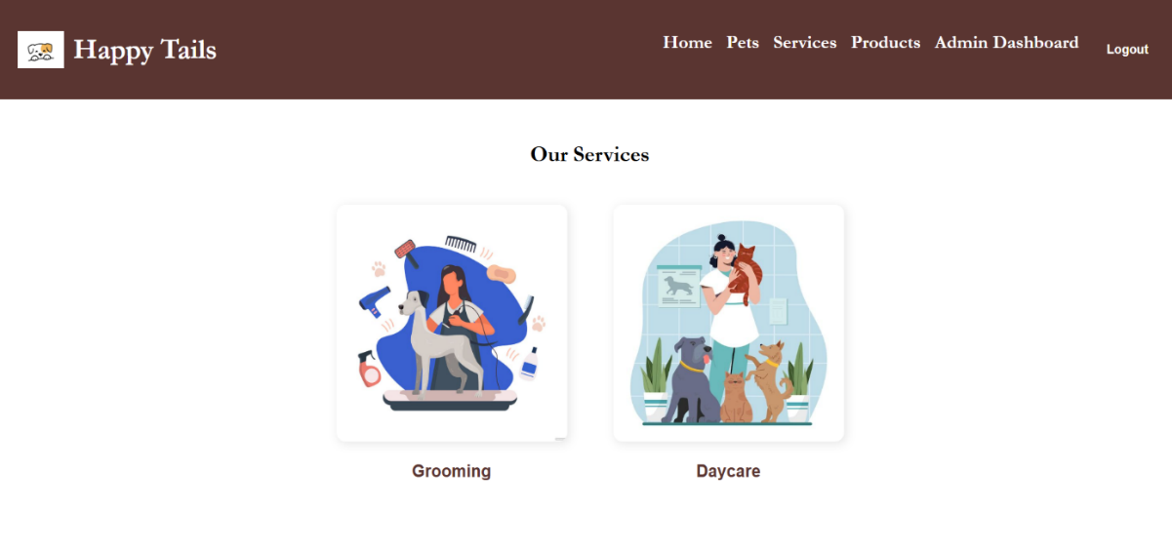

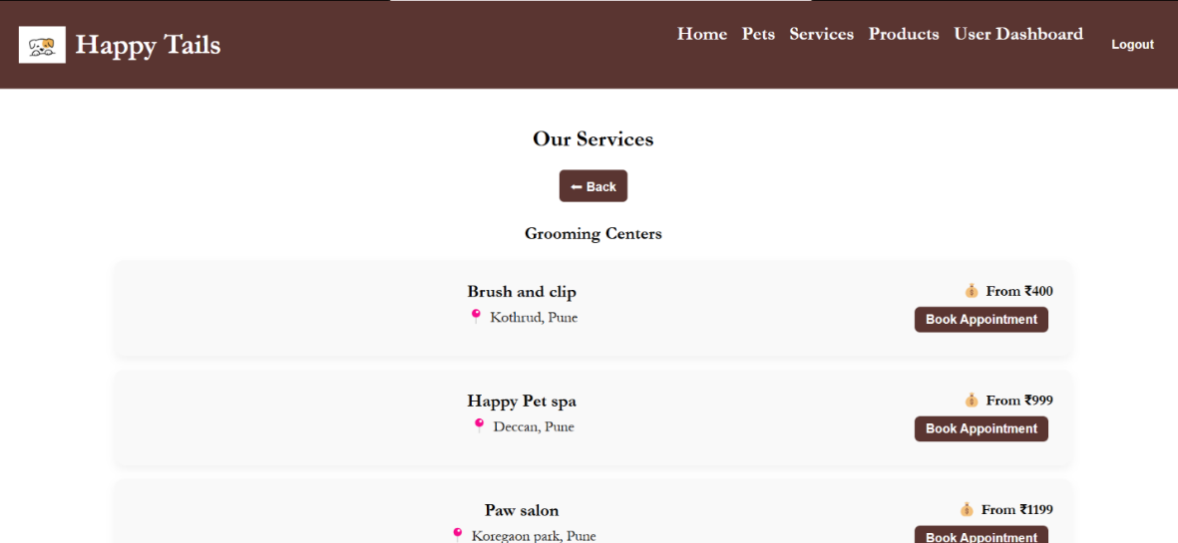

* 1. Pets Page

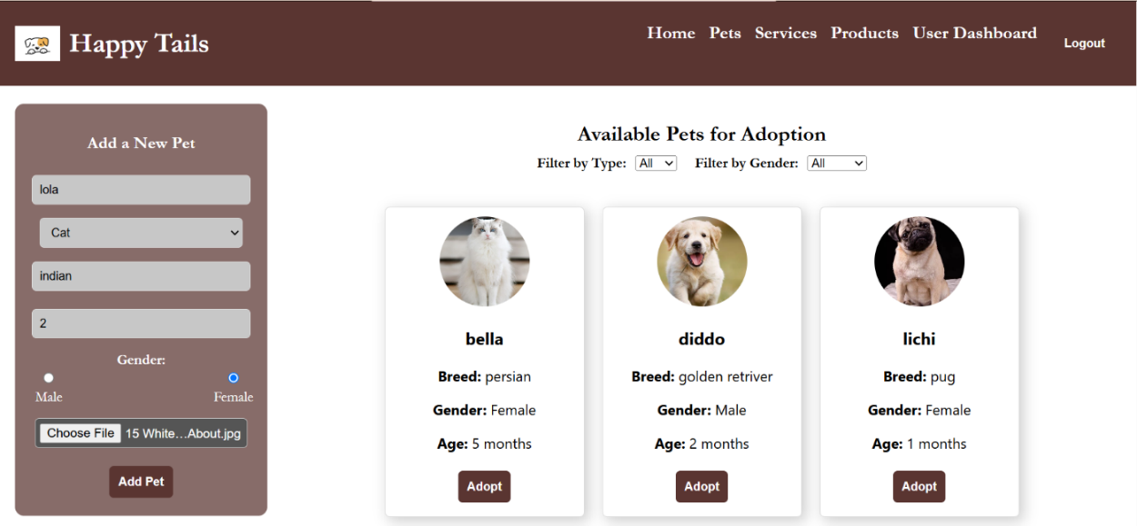

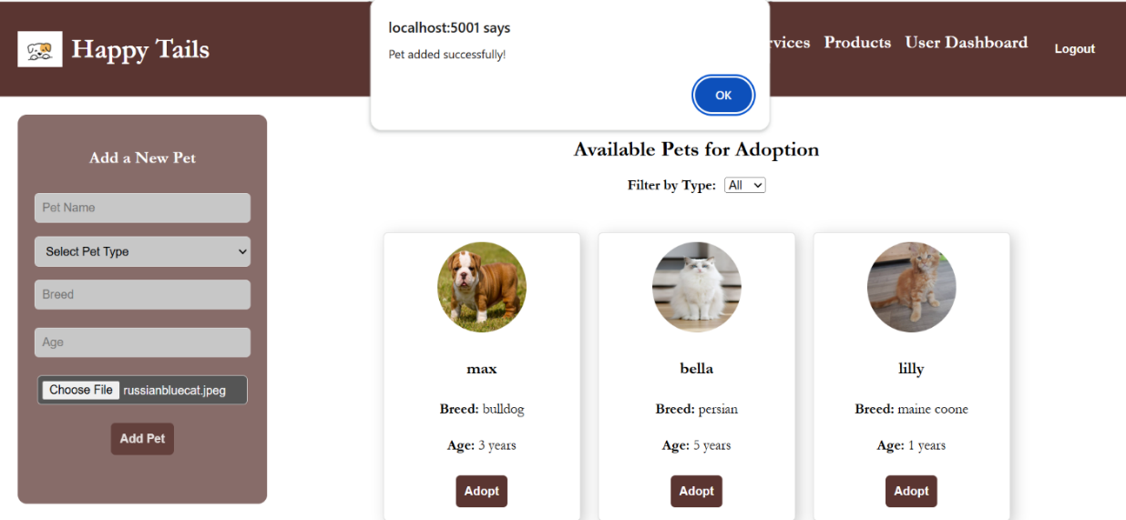

* 1. User Dashboard

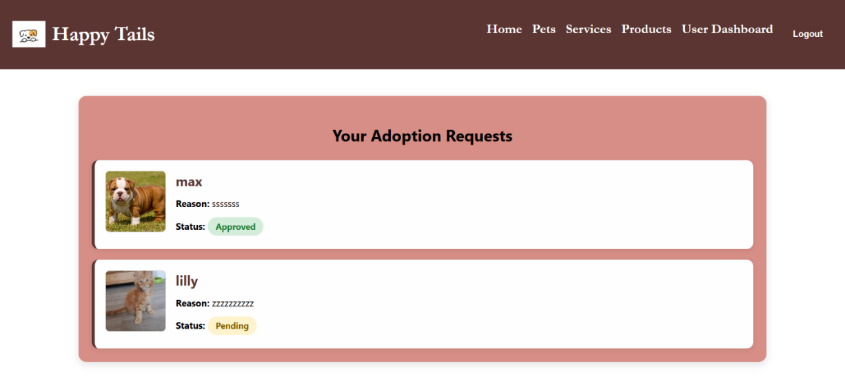

* 1. Admin Dashboard

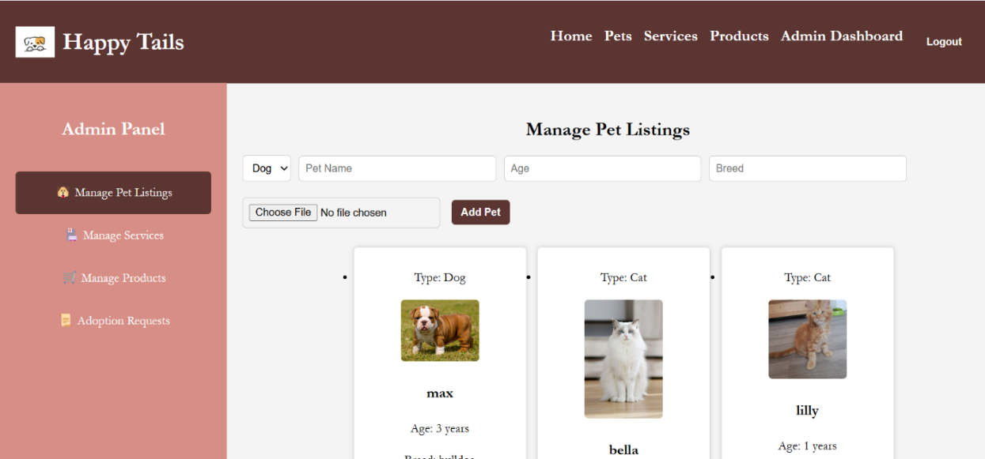

Chapter 4

**CODING**

**4.1. Code snippets**

server.mjs –

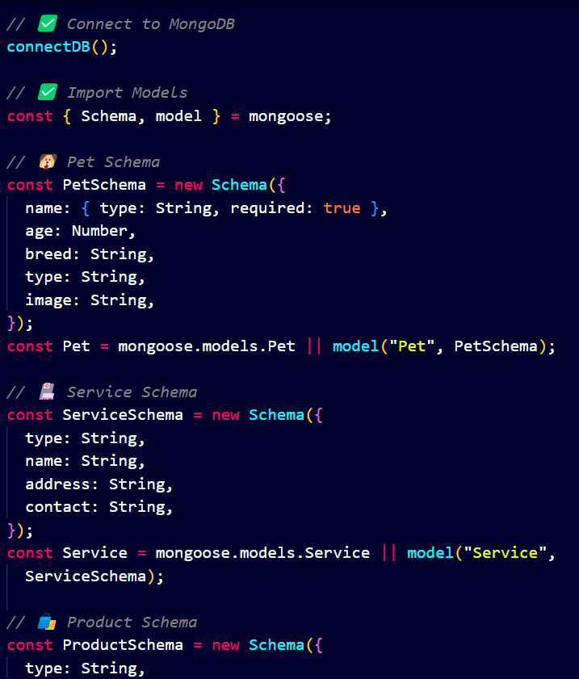

home.js -

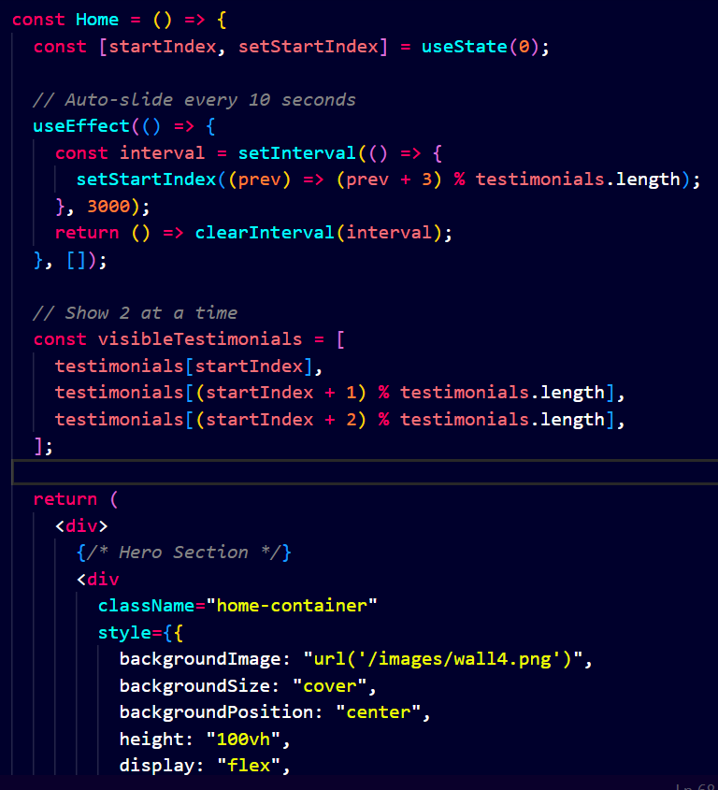

adoptionForm.js -

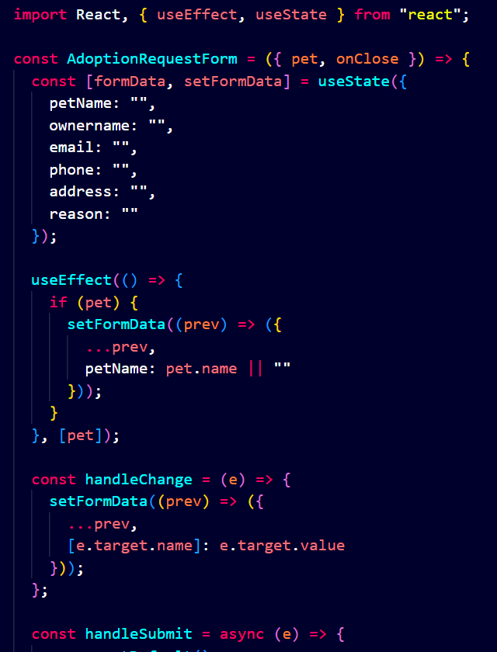

petListings.js –

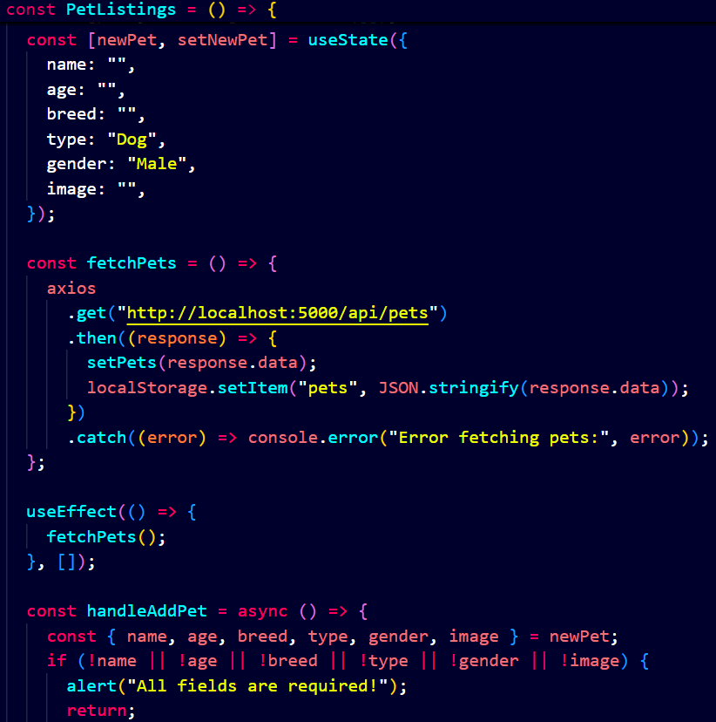

Chapter 5

**TESTING**

* 1. **Test Strategy**
     1. Introduction : This document outlines the test strategy for the MERN-based Pet Adoption and eCommerce Platform, ensuring quality, functionality, performance, and security.
     2. Objectives :
     + Verify core functionalities, including user authentication, pet adoption, and eCommerce operations.
     + Ensure smooth user and admin interactions.
     + Validate database operations (MongoDB).
     + Test UI/UX for responsiveness and consistency.
     + Ensure secure payment transactions.
     1. Scope :

1. Functional Testing –

* User authentication (login, logout, role-based access).
* Pet listing, adding, editing, and deletion (admin and users).
* Adoption request submission, approval, and status updates.
* Product management (adding, deleting, viewing products).
* Cart operations (adding, removing items, proceeding to checkout).
* Payment gateway functionality.

1. Non-functional Testing –

* **Performance Testing:** Load and stress testing for high traffic handling.
* **Security Testing:** Prevent SQL injection, XSS, and ensure secure payment transactions.
* **Usability Testing:** Ensure a smooth user experience across different devices and screen sizes.
  + 1. Testing Approach :
* **Manual Testing:** UI, functional flows, and edge cases.
* **Automation Testing:** Use Selenium for UI testing and Jest/Mocha for backend unit testing.
* **API Testing:** Postman for endpoint validation.
  + 1. Test Environment :
* **Frontend:** React.js
* **Backend:** Node.js, Express.js
* **Database:** MongoDB
* **Test Frameworks:** Jest, Mocha, Selenium
* **Tools:** Postman
  + 1. Test Execution :
* **Unit Testing:** Individual component testing.
* **Integration Testing:** Validate communication between modules.
* **System Testing:** End-to-end testing.
* **User Acceptance Testing (UAT):** Validate against business requirements.
  + 1. Risk and Mitigation Plan :

|  |  |
| --- | --- |
| **Risk** | **Mitigation** |
| Payment failures | Implement retry and logging |
| Data inconsistency | Regular database backups |
| High traffic crash | Load testing and scaling |

* + 1. Conclusion : This strategy ensures a robust, scalable, and secure platform by covering all essential test areas. Testing will be continuously improved based on feedback and iterations

**5.2 Unit Test Plan**

5.2.1. Introduction - This document outlines the unit test plan for HappyTails, a MERN-based pet adoption and eCommerce platform. The goal is to ensure individual components function correctly before integration.

5.2.2. Scope - Unit tests will cover backend APIs, frontend components, database interactions, and authentication mechanisms

5.2.3. Testing tools –

* Backend: Jest, Supertest (for API testing)
* Frontend: React Testing Library, Jest
* Database: MongoDB memory server for isolated tests

5.2.4. Test Cases –

|  |  |  |  |  |  |
| --- | --- | --- | --- | --- | --- |
| **Test Case ID** | **Test Category** | **Test Case Description** | **Input Steps** | **Expected Output** | **Status** |
| TC-01 | Login | Test user login with valid credentials | 1. Enter email, password  2. Click "Login" | Redirect to Pets page | Pass |
| TC-02 | Login | Test login with invalid credentials | 1. Enter wrong email or password  2. Click "Login" | Show "Invalid credentials" message | Pass |
| TC-03 | Pet Listing | Add pet by admin | 1. Login as admin  2. Go to Admin  3. Dashboard Add Pet  4. Submit | Pet is visible in Pets page | Pass |
| TC-04 | Adoption | User sends adoption request | 1. Login  2. Pets page  3. Click "Adopt"  4. Fill form Submit | Request is sent and shown in User Dashboard | Pass |
| TC-05 | Adoption | Admin updates status | 1. Admin Dashboard  2. View requests  3. Click "Approve/Reject" | Status updates for user | Pass |
| TC-06 | Services | View all services as user | 1. Login as user  2. Go to Services page | Both Grooming & Daycare services are visible | Pass |
| TC-07 | Products | User adds product to cart | 1. Products page  2. Click "Add to Cart" on a product | Product is shown in cart | Pass |
| TC-08 | Navbar | Navbar visibility before login | 1. Load homepage before login | Show: Home, Login | Pass |
| TC-09 | Payment | User buys a product | 1. Add to cart  2. Click "Buy Now"  3. Complete payment flow | Show "Payment Successful" and confirmation message | Pass |
| TC-10 | Navbar | Navbar after user login | 1. Login as user | Show: Home, User Dashboard, Pets, Products, Services, Logout | Pass |
| TC-11 | Navbar | Navbar after admin login | 1. Login as admin | Show: Home, Admin Dashboard, Pets, Products, Services, Logout | Pass |

5.2.5. Conclusion - The above unit test plan ensures HappyTails is robust and functional. These test cases will be executed before deployment to guarantee smooth operation of the platform.

* 1. **Acceptance Test Plan**

### **1. Project Information**

### **Project Name:** HappyTails – Pet Adoption & E-Commerce Platform **Developed By:** Sakshi Nikalje **Technology Stack:** MERN (MongoDB, Express.js, React.js, Node.js) **Database:** MongoDB (Database: petManagement)

### **2. Objective**

The objective of HappyTails is to create a comprehensive platform for pet adoption and pet product sales. The system allows users to browse and adopt pets, purchase pet-related products, and access pet care services. Admins can manage pet listings, adoption requests, and product inventory efficiently.

1. Scope
   * + Users can register, log in, and manage their profiles.
     + Pet adoption functionality, allowing users to browse, request adoption, and track request statuses.
     + E-commerce features, including product listings, shopping cart, and payment gateway.
     + Admin dashboard for managing pets, products, services, and adoption requests.
     + Service listings (Grooming & Daycare) that users can view but only admins can add.
2. Test Environment
   * + **Frontend:** React.js (Running on localhost:3001)
     + **Backend:** Node.js with Express.js (Running on localhost:5000)
     + **Database:** MongoDB (petManagement database)
     + **Testing Tools:** Postman (API Testing)
     + **Browser Compatibility:** Chrome, Firefox, Edge
3. Acceptance Criteria

* Users should be able to register and log in successfully.
* Pets should be displayed correctly, and users should be able to view pet details and request adoption.
* Admin should be able to approve/reject adoption requests, and users should see the status updates.
* Products should be listed, added to the cart, and purchased via the payment gateway.
* Services should be visible to all users, but only admins should manage them.
* Admin should be able to add/edit/delete pets, products, and services.
* UI should be responsive and work on desktop and mobile screens.

1. Test Data

* User Login: Test with valid and invalid credentials.
* Pet Adoption: Submit requests with valid details and check status updates.
* Product Purchase: Add items to the cart, remove items, and proceed with payment.
* Admin Management: Add pets, approve adoption requests, and delete products.

1. Test Cases

|  |  |  |  |  |  |  |
| --- | --- | --- | --- | --- | --- | --- |
| **Test Case ID** | **Feature** | **Scenario** | **Preconditions** | **Test Steps** | **Expected Outcome** | **Status** |
| TC-12 | Login System | User logs in successfully | User has a valid account | 1. Go to Login | User is redirected to the User Dashboard | Pass |
| 2. Enter email/password |
| 3. Click Login |
| TC-13 | Pet Listing | User adds a pet | User is logged in | 1. Go to Pets | New pet appears in the Pets list | Pass |
| 2. Fill Add Pet form |
| 3. Click Add Pet |
| TC-14 | Adoption Process | Admin reviews and approves request | Admin is logged in, requests exist | 1. Go to Admin Dashboard | Request status updates to "Approved" | Pass |
| 2. View Requests |
| 3. Click Approve |
| TC-15 | Services | Admin adds a grooming center | Admin is logged in | 1. Go to Admin Dashboard | Service appears under Grooming | Pass |
| 2. Add Service (Grooming) |
| 3. Submit |
| TC-16 | Product Management | Admin adds a product | Admin is logged in | 1. Go to Admin Dashboard | Product appears on Products page | Pass |
| 2. Add product |
| 3. Submit |
| TC-17 | Shopping Cart | User adds/removes product from cart | User is logged in | 1. Go to Products | Product appears/gets removed from cart | Pass |
| 2. Click Add to Cart |
| 3. View cart |
| 4. Click Remove |
| TC-18 | Payment Gateway | User completes a purchase | User has items in cart | 1. Go to Cart | Show "Payment Successful", "Order Confirmed" | Pass |
| 2. Click Buy Now |
| 3. Complete payment |
| TC-19 | Adoption Status | User sees updated status | Admin has taken action | 1. Submit adoption request | Status shows "Approved" or "Rejected" | Pass |
| 2. Admin approves |
| 3. User views dashboard |

### **Deliverables**

* Test cases and execution report.
* Bug report (if any).
* Deployment-ready system after acceptance testing.
* Final documentation for functionality and database structure.

### **Risk Assessment**

* **Data Loss:** Regular database backups needed.
* **Security Issues:** Implement authentication and authorization properly.
* **Payment Gateway Failures:** Use a reliable provider and test multiple scenarios.
* **Performance Issues:** Optimize API calls and database queries.
* **User Experience:** Ensure a smooth UI with no major usability issues.
  1. **Test Cases**

1. **Authentication**

|  |  |  |  |  |
| --- | --- | --- | --- | --- |
| **Test Case ID** | **Description** | **Input** | **Expected output** | **Status** |
| TC-20 | Login with valid credentials | Correct email & password | Successful login, redirect to respective dashboard | Pass |
| TC-21 | Login with invalid credentials | Wrong email or password | Error message: "Invalid credentials" | Pass |
| TC-22 | Register new user | Unique email, valid details | Account created, redirected to login page | Pass |

1. **Pet Listing & Adoption Requests**

|  |  |  |  |  |
| --- | --- | --- | --- | --- |
| **Test Case ID** | **Description** | **Input** | **Expected output** | **Status** |
| TC-23 | Add a new pet (User/Admin) | Valid pet details | Pet appears in the pet page | Pass |
| TC-24 | Submit an adoption request | Fill form & submit | Request appears in admin dashboard | Pass |
| TC-25 | Admin approves/rejects request | Click approve/reject | Status updates in user dashboard | Pass |

1. **Product Management**

|  |  |  |  |  |
| --- | --- | --- | --- | --- |
| **Test Case ID** | **Description** | **Input** | **Expected output** | **Status** |
| TC-26 | Admin adds a new product | Valid product details | Product appears in the products page | Pass |
| TC-27 | Admin deletes a product | Click delete | Product removed from listing | Pass |
| TC-28 | User views products | Navigate to products page | Product list loads properly | Pass |
| TC-29 | Add product to cart | Click "Add to Cart" | Product appears in cart | Pass |
| TC-30 | Checkout process | Click "Buy Now" & enter payment details | Payment gateway opens | Pass |
| TC-31 | Payment success | |  | | --- | |  |  |  | | --- | |  |   Correct details and make payment | Confirmation message & delivery time | Pass |

1. **Services Management**

|  |  |  |  |  |
| --- | --- | --- | --- | --- |
| **Test Case ID** | **Description** | **Input** | **Expected output** | **Status** |
| TC-32 | Admin adds a new service | Valid service details (name, category, details) | Service appears on the Services page | Pass |
| TC-33 | Admin tries to add service without address | Leave address blank | Error: "Address is required" | Pass |
| TC-34 | Admin deletes a service | Click "Delete" on a service | Service removed from the Services page | Pass |
| TC-35 | Book appointment | Click “Book appointment” | Contact of service center and whatsapp chat icon appears | Pass |

1. **Admin Dashboard**

|  |  |  |  |  |
| --- | --- | --- | --- | --- |
| **Test Case ID** | **Description** | **Input** | **Expected output** | **Status** |
| TC-36 | View all adoption requests | Go to adoption requests section | List of all pending/completed requests | Pass |
| TC-37 | Manage pets | Add/delete pets | Changes reflect in user view | Pass |
| TC-38 | Manage products | Add/delete products | Changes reflect in user view | Pass |
| TC-39 | Manage services | Add/delete services | Changes reflect in user view | Pass |

* 1. **Defect report**

1. Project Information

Project Name: HappyTails – Pet Adoption & E-Commerce Platform  
Reported By: Sakshi Nikalje  
Reported Date: 02/04/2025  
Tested Environment:

* Frontend: React.js (Running on localhost:3001)
* Backend: Node.js with Express.js (Running on localhost:5000)
* Database: MongoDB (petManagement database)
* Browser: Chrome, Firefox
* Testing Tools: Postman

1. Defect summary
   * + **Total Defects Found:** [Number of Defects]
     + **Severity Levels:** Critical, Major, Minor
2. Defect list

* **Large Pet Images Not Getting Added**

Description: When attempting to add a pet with a large image file (e.g., high resolution or large file size), the image upload fails or the form submission is blocked.

Possible Causes:

* + Backend/server not handling large file sizes.
  + Missing file size validation or compression.
  + Frontend timeout during upload.

Severity: High

Suggested Fix:

* + Increase file size limit on backend (e.g., using multer for Node.js).
  + Add frontend validation and compression before upload.
  + Show user-friendly error message on failure.
* **No Notification on Updated Adoption Request Status**

Description: When the admin updates the status of an adoption request (e.g., Approved/Rejected), the user is not notified, and no real-time or visual update is shown in the user dashboard.

Possible Causes:

* + Missing socket or polling logic to reflect real-time updates.
  + No toast/alert/notification system implemented.
  + API response not linked to UI update.

Severity: Medium

Suggested Fix:

* + Implement real-time updates using WebSockets or polling.
  + Add toast or alert notifications in the UI for status changes.
  + Ensure status field in UI reflects latest database state.

### **Conclusion & Next Steps**

* Developers will investigate and fix the defects based on priority.
* Testers will re-execute test cases after fixes to confirm resolution.
* A retest report will be generated post-fix implementation.

Chapter 6 **LIMITATIONS OF PROPOSED SYSTEM**

**Limitations :**

* 1. No Real-Time Notifications –
* Users do not receive real-time alerts when an adoption request is approved/rejected.
* Admins are not notified immediately when a new pet or adoption request is added.
  1. No AI-Based Recommendations –
* The system does not suggest pets based on user preferences.
* Product recommendations are not personalized.
  1. No Multi-Language Support –
* The platform supports only one language (English), limiting accessibility for non-English speakers.

Chapter 7

**PROPOSED ENHANCEMENTS**

**Future Enhancements :**

1. Real-Time Notifications

Enhancement: Use WebSockets (Socket.io) or Firebase to send real-time updates.  
Benefit:

* + Users get instant notifications when their adoption request is approved/rejected.
  + Admins receive alerts when a new adoption request is submitted.

2. AI-Based Pet & Product Recommendations

Enhancement: Implement Machine Learning (ML) algorithms to suggest pets and products based on user behaviour.  
Benefit:

* Personalized pet recommendations based on breed, age, and past searches.
* Users see pet products relevant to their browsing history.

Chapter 8

**CONCLUSION**

**Conclusion :**

The HappyTails Pet Adoption & eCommerce Platform is a MERN-based web application designed to streamline pet adoption and pet product purchases. The system enables users to browse and adopt pets, while also offering an admin dashboard for managing pet listings, adoption requests, products, and services. However, with future enhancements like automated adoption processing, role-based access control, multi-language support, and a mobile app, it can become a more user-friendly and scalable platform for pet lovers and pet service providers. This project demonstrates how technology can bridge the gap between pet seekers and pet providers, promoting responsible pet adoption and enhancing pet care services. The integration of admin-controlled pet and service management ensures that only verified listings are displayed, increasing trust and transparency. By leveraging MongoDB, Express.js, React, and Node.js, the platform maintains a robust and scalable architecture that can handle increasing user traffic and data efficiently. Future integrations such as geo-location-based pet searches and AI-powered pet recommendations can further enhance user engagement and personalization.

Chapter 9

**Bibliography**

**Bibliography :**

1. **MongoDB Documentation**  
   MongoDB, Inc. (n.d.). MongoDB Manual*.* Retrieved from <https://www.mongodb.com/docs/manual/>
2. **Express.js Guide**  
   Express.js. (n.d.). Express - Node.js web application framework*.* Retrieved from <https://expressjs.com/>
3. **React Official Documentation**  
   Meta. (n.d.). React – A JavaScript library for building user interfaces*.* Retrieved from https://reactjs.org/docs/getting-started.html
4. **Node.js Documentation**  
   OpenJS Foundation. (n.d.). Node.js. Retrieved from https://nodejs.org/en/docs/
5. **Mongoose ODM**  
   Mongoose. (n.d.). Mongoose: Elegant MongoDB object modeling for Node.js*.* Retrieved from <https://mongoosejs.com/>
6. **React Router**  
   Remix Software. (n.d.). React Router Documentation. Retrieved from <https://reactrouter.com/>

Chapter 10  
  
**USER MANUAL**

**1. Registration & Login**

1.1 Registration Screen

* Purpose: To allow new users to create an account.
* Fields:
  + Username: Required, must be unique.
  + Email: Required, must be a valid email format.
  + Password: Required, minimum 6 characters.
* Validations:
  + All fields are mandatory.
  + Proper error messages for duplicate emails or weak passwords.

1.2 Login Screen

* Purpose: To authenticate existing users/admins.
* Fields:
  + Email
  + Password
* Validations:
  + Must enter correct email-password combination.
  + Error shown for invalid credentials.

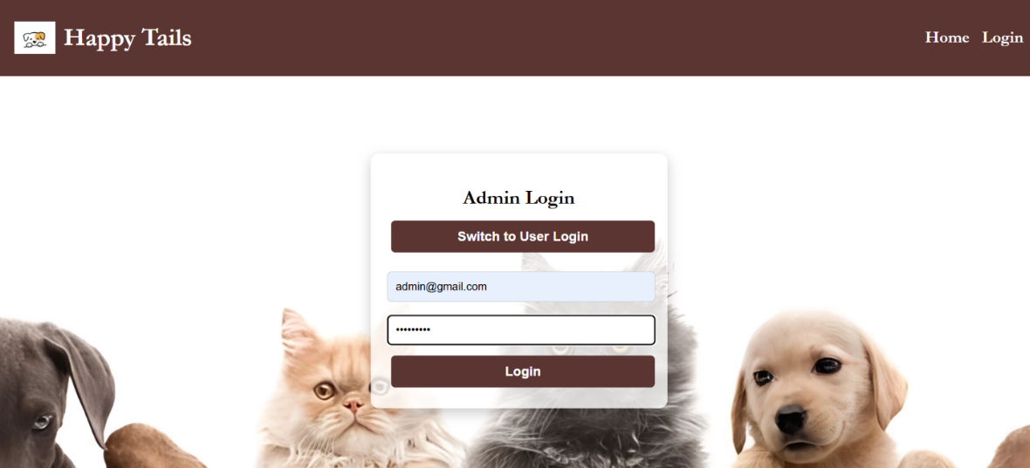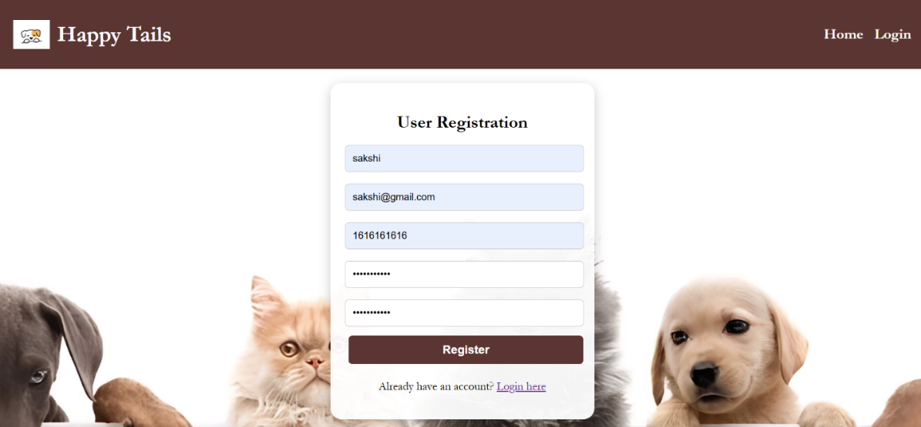

**2. Home Page**

* Purpose: Landing page after login.
* User Role View:
* welcome message
* navigation to pets, services, products, etc.
* happy customers feedback displayed

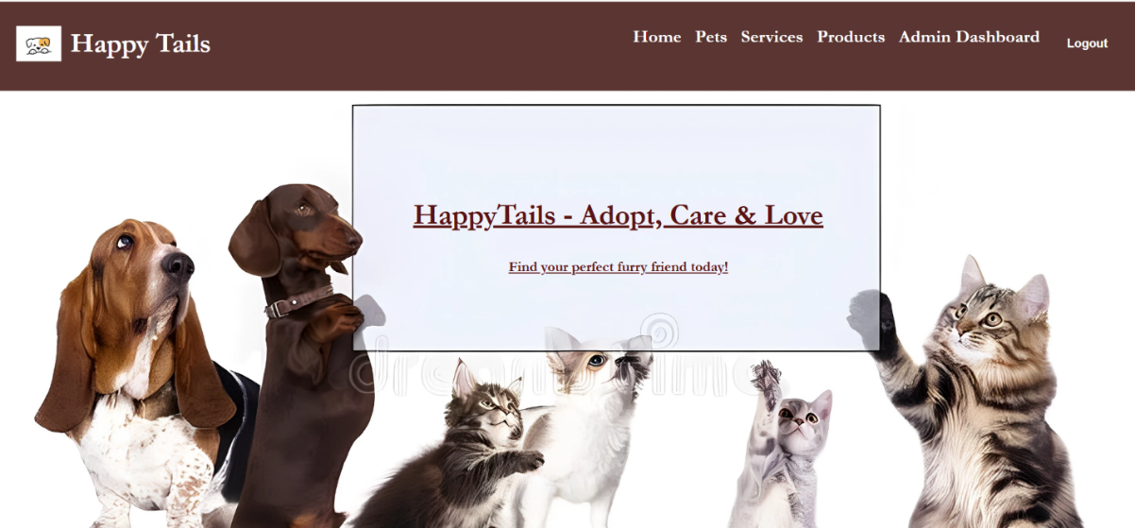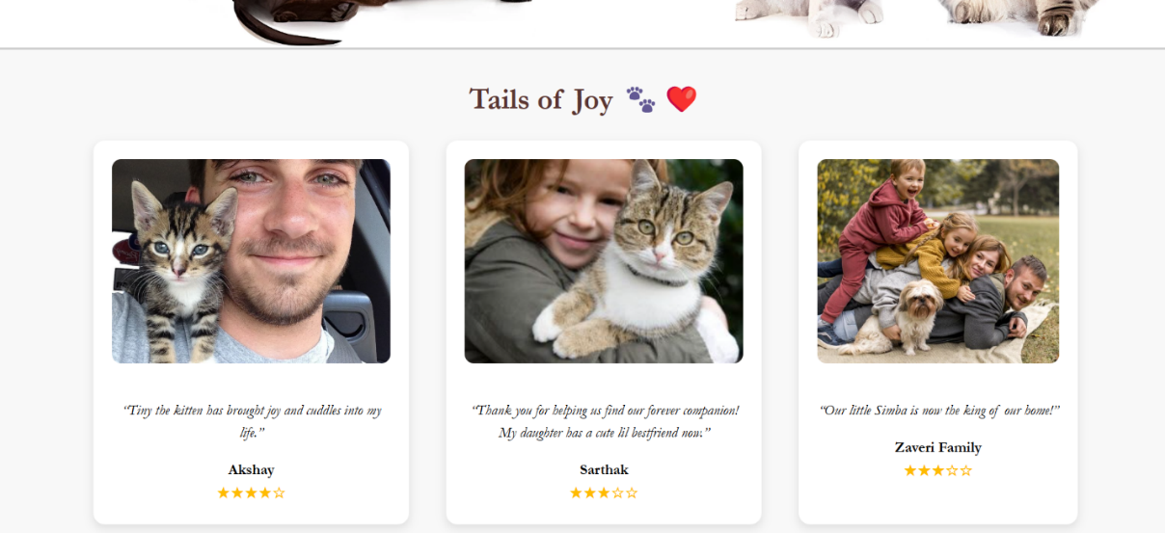

**3. Pets Page**

For Users:

* Purpose: View adoptable pets.
* Features:
  + View pet name, type, breed, image, and description.
  + Click "Adopt" to open the adoption request form.
* Validations (Adoption Form):
  + Name, contact number, reason for adoption are required.
  + Phone number must be numeric and 10 digits.

For Admins:

* Purpose: Manage all pet listings.
* Features:
  + Add/Edit/Delete pets.
* Validations:
  + Pet Name, Age, Type, Breed, and Image are mandatory.
  + Age must be a positive number.
  + Image file size limit (e.g., max 2MB).

Add Pet (User/Admin):

* Form Fields: Name, Age, Breed, Type, Details, Image.
* Validations:
  + All fields are required.
  + Age must be a number.
  + Image should be in .jpg/.png and within size limit.

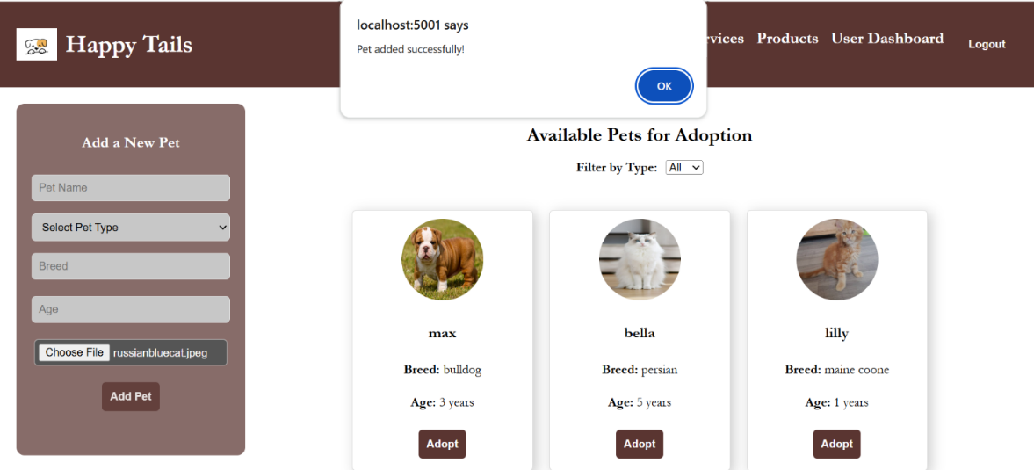

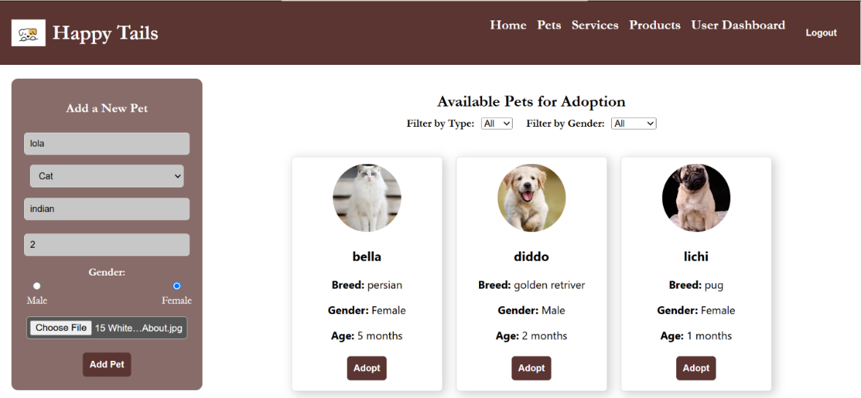

**4. Products Page**

* Purpose: Users can browse and add pet-related products to the cart.
* Features:
  + Filter products by category (Food, Clothes, Toys).
  + Add to Cart / Buy Now options.

Cart Section:

* Shows all items added by the user.
* Allows removal or proceeding to payment.

Validations:

* Cannot add duplicate items.
* Cart must have at least one item to proceed to payment.

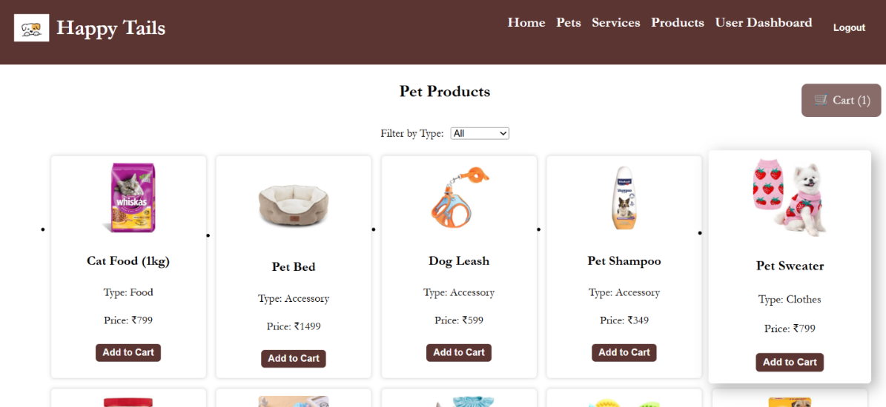

1. **Services Page**

#### **Purpose**:**** To display all available pet-related services categorized as **Grooming** and **Daycare**, and allow users to **book appointments**.

Features:

* Categorized View:
  + Grooming Centers
  + Daycare Centers
  + Each category has cards/lists showing:
    - Service Name
    - Location
    - Description (optional)
* Book Appointment Button:
  + Available on each service listing.
  + On click, it reveals the Contact Number of the service provider.
  + Optionally, can also show a simple message like "Please contact to schedule your appointment."

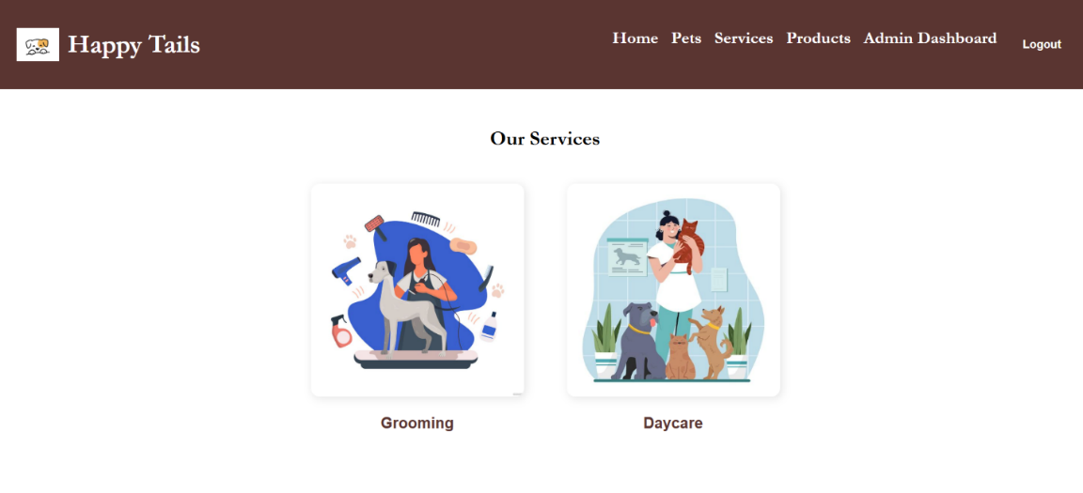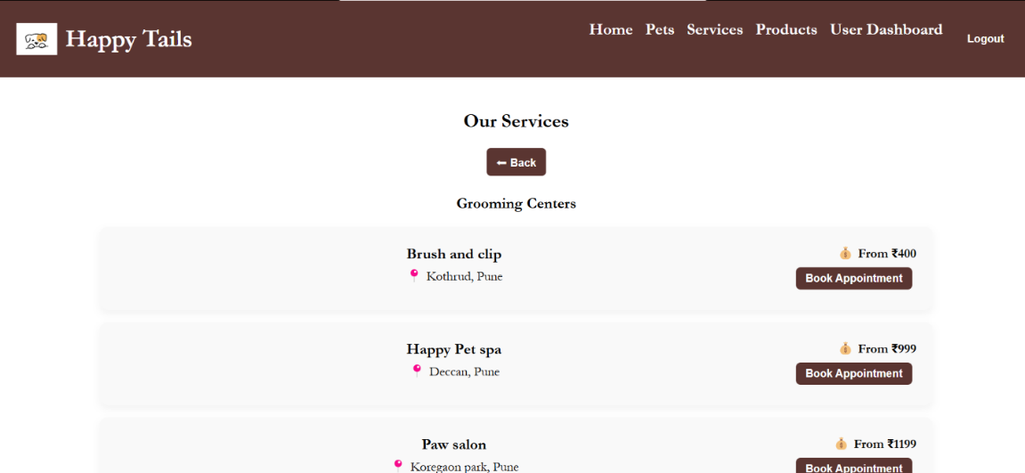

1. **Admin Dashboard**

* Purpose: Central control panel for admin.
* Sections:
  + Manage Users (if needed)
  + View and update Adoption Requests
  + Manage Pets and Products
  + Add Grooming/Daycare Services

Adoption Requests Management:

* Admin can view user-submitted requests and click to Approve or Reject.
* Status updates are saved in the database.

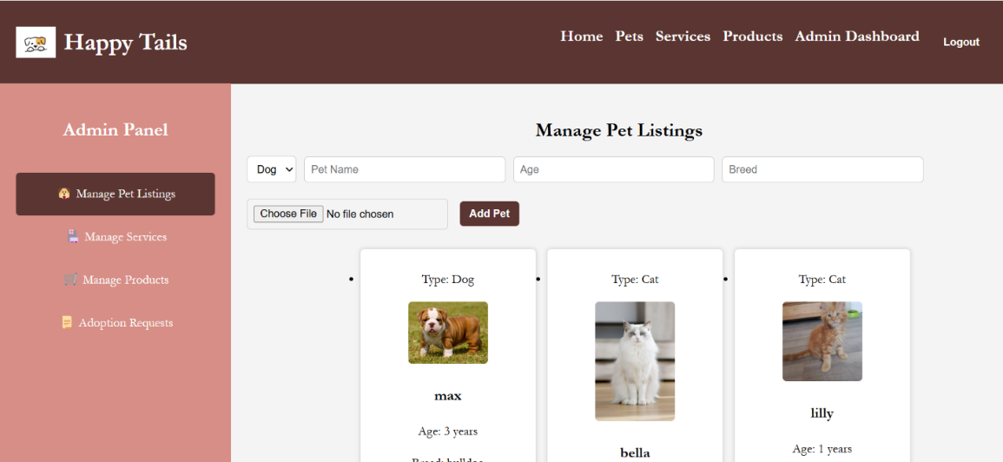

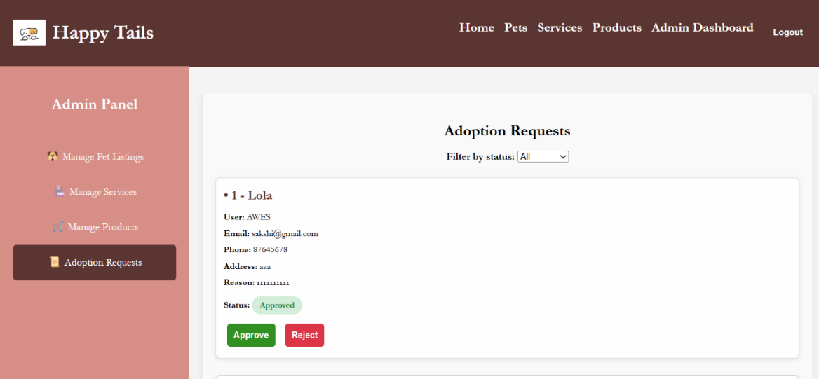

1. **Error Handling & Errors**

* **Invalid Inputs**: Display form-specific validation messages.
* **No Notification Issue** (Known Bug): Status change messages not popping up yet.

